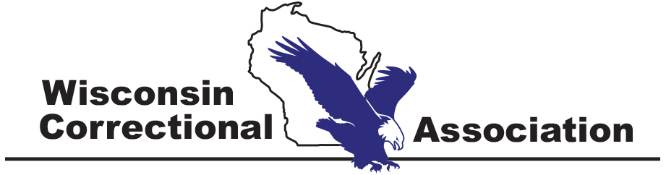

40th Annual Conference

October 2-4, 2022

Elkhart Lake, Wisconsin

EXHIBITOR & SPONSORSHIP
OPPORTUNITIES

EXHIBITOR & SPONSORSHIP FACT SHEET
BACKGROUND
Since 1985, the Wisconsin Correctional Association has been dedicated to providing a forum for the Wisconsin correctional community and positively impacting the criminal justice system in Wisconsin for those both within the system and the public at large. The WCA recognizes the importance of a wide range of members from federal, state, county, local and community employers as well as our universities and colleges related to corrections. We welcome members from all fields. Our mission is to provide a focal point for the identification of interests and concerns for corrections as part of the criminal justice system in Wisconsin. We also strive to provide an opportunity for active participation in professional development for those employed in corrections in Wisconsin.

VALUE OF PARTNERSHIP

When you participate in the Wisconsin Correctional Association Conference as an exhibitor and/or sponsor, your organization’s message will directly reach more than 300 individuals at the conference including correctional officers, social workers, probation and parole agents, executive staff, wardens, administrators, first-line supervisors, county jail staff, treatment providers, court staff, professors, students and other professionals in the criminal justice field. In turn, these individuals bring your marketing materials and products to their decision makers, workgroups and committees to discuss potentially utilizing your services.

ANTICIPATED ATTENDANCE

- More than 300 attendees from all areas of corrections
- Chief Executives, Managers and Supervisors
- Municipal, county, state, and federal agency staff
- Non-profit and private organizations
- Other exhibitors for networking

CONFERENCE STRUCTURE
Two and a half days of activities, including general sessions for all, breakout sessions for specific areas of interest, a networking reception and other activities for those who attend.

Visit the WCA website at www.wcatoday.com to learn more about WCA and the conference!

Questions regarding exhibiting or sponsorships can be directed to:
Ashley Melanson WCAExhibitors@gmail.com or (262) 325-5168

EXHIBITOR CONFERENCE SCHEDULE

Sunday, October 2 Monday, October 3
3:00pm – 4:30pm 6:00 – 7:00pm Booth Setup Dinner and Meet & Greet w/Board - exclusive event to meet the WCA conference committee and board  7:00 – 9:00pm President’s Welcome Reception  9:00 – 9:30pm Booth Setup  PRESIDENT’S RECEPTION  The President’s Reception is a great networking opportunity as you enjoy time with other conference attendees. You will also get a chance to present your company/organization/school in front of those in attendance!  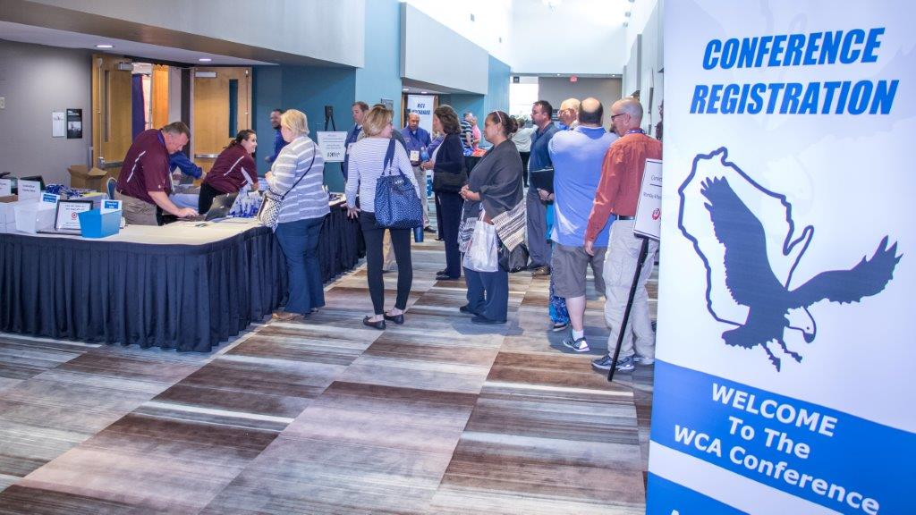 | 6:00am-7:00am 7:00am–8:00am Booth Setup Breakfast & Networking with Exhibitors  8:00am – 9:30am Opening Ceremony/Keynote  9:30am – 10:00am Attendee/Exhibitor Time  10:00am–11:30am Breakout Session I  11:30am–12:00pm Attendee/Exhibitor Time  12:00pm – 1:30pm Awards Luncheon  1:30pm – 3:00pm 3:00pm – 3:30pm Breakout Session II Attendee/Exhibitor Time  3:30pm – 5:00pm 5:00pm – 5:30pm 5:30pm – 6:00pm Breakout Session III Stamp Card Raffle Drawing Exhibitor booth breakdown  6:30pm Social Hour  7:00pm – 11:00pm Celebration & Entertainment with Appetizers*  MONDAY NIGHT  CONFERENCE CELEBRATION  Join the attendees and other exhibitors for a conference celebration with entertainment and other activities. This will be a great opportunity to interact with attendees and enjoy complimentary beverages and appetizers.  *Please consider sponsoring this event and be recognized during the event! See Sponsor form for details.

EXHIBITOR INFORMATION

Register for your booth today! Your registration includes:
BOOTH COST
Single = $450
Double = $900
- Company name on WCA website
- One 6’ table and two chairs in a fully draped booth
- One booth ID Sign
- Admission to Meet & Greet Dinner, Welcome Reception, Entertainment Night and the entire conference
- 2 meal tickets for each meal

STAMP CARD RAFFLE
The Stamp Card Raffle is a great and easy opportunity to guarantee attendees to visit your booth and to educate them about your company/organization/school.
This Stamp Card Raffle will require you to provide 2 questions about your company/organization/school in which the attendees will come to your booth and ask. We encourage you to have them ask you the question and engage in conversation before you sign off on their card rather than just signing.
The raffle drawing will take place on Monday at 5pm.
*Please note that only Stamp Card Raffle participants will be allowed to present their prizes at 5pm on Monday. If you are promoting an independent raffle at your booth, you are responsible for contacting the winner and presenting your prize to that individual.

WHY BE AN EXHIBITOR?
The WCA has worked to ensure our exhibitors are recognized throughout the conference for their generous support. In order to do this, we have established specific activities that will bring conference attendees to you and your booths!
- Breaks will be held in the exhibitor area
- Lunch will be held in the exhibitor area
- Exhibitor Stamp Card Raffle drawing will be held in the exhibitor area
- Two different social events with attendees
We are here to support your success and help you be visible to all attendees.

SPONSORSHIP OPPORTUNITIES
We have a number of options to fit your budget and will work with you if you have another idea for sponsorship as well! Great advertising and networking opportunities!

Platinum Level - $8,000
- Name listed on WCA website
- 1- double booth rental
- Two full page ads in conference program
- Four additional conference meal tickets
- Individual signage at conference showing sponsorship level
- Verbal & digital recognition throughout the entire conference

Gold Level - $5,000
- Name listed on WCA website
- 1- double booth rental
- Full page ad and half page ad in conference program
- Four additional conference meal tickets
- Individual signage at conference showing sponsorship level
- Verbal & digital recognition throughout the entire conference
Silver Level - $3,000
- Name listed on WCA website
- 1 – single booth rental
- Full page ad in conference program
- Two additional conference meal tickets
- Signage, verbal & digital recognition throughout the entire conference
Bronze Level - $1,500
- Name listed on WCA website
- 1 – single booth rental
- Half page ad in conference program
- Signage, verbal & digital recognition throughout the entire conference

Monday Night Celebration Sponsorship - $3,000
- Name listed on WCA website
- 1 – single booth rental
- Half page ad in conference program
- Two additional conference meal tickets
- Signage, verbal & digital recognition at the event & during conference
Keynote Sponsorship - $350/each
- Name listed on WCA website
- Quarter page ad in conference program
- Signage, verbal & digital recognition throughout the conference
Breakout Session Sponsorship - $150/each
- Name listed on WCA website
- Signage, verbal & digital recognition throughout the conference

ADVERTISING OPPORTUNITIES

You can advertise directly in the 8.5”x11” conference program that every attendee receives. This is a great opportunity to advertise your company/organization/school!

RETURNING THIS YEAR:

You now have the opportunity to purchase signage for the conference to be placed at various locations of the conference of your choice. See below for sizes and pricing.

CONFERENCE AD PLACEMENT (check all that apply)

Full Page Print Ad(s)
$250 each Ad ☐Conference Program

½ Page Print Ad(s)
$150 each Ad ☐Conference Program

¼ Page Print Ad(s)
$100 each Ad ☐Conference Program

CONFERENCE ADVERTISING (check all the apply)

Signage at the conference ☐24”x36” full color sign ☐18”x 24” full color sign
Your logo on a sign placed in $120/each $70/each
the conference area
of your choice

EXHIBITOR REGISTRATION FORM

Select your booth size (check one) Select your set-up time (check one)
☐ Single Booth ☐ Sunday 3pm – 4:30pm
☐ Double Booth ☐ Sunday 9pm – 9:30pm
☐ Monday 6am – 7am
Company/Organization/School Name: Enter Company/Organization/School Name
Contact Name: Enter Company/Organization/School Contact Name
Phone Number: Enter Phone Number
Email Address: Enter Email Address
Company/Organization/School Website: Enter Website Address
Contact Name for Conference Program: Enter Name

Contact Email & Phone Number for Conference Program: Enter Email & Number

Booth Identification Sign (exactly how it should read): Enter Signage Name

Attendee #1 Name Badge: Enter First & Last Name
Meal Accommodations? (Vegetarian, Vegan, Gluten Free, etc.) Enter Needs Here
Attending the Meet & Greet dinner on Sunday at 6pm? ☐ Yes ☐ No

Attendee #2 Name Badge: Enter First & Last Name
Meal Accommodations? (Vegetarian, Vegan, Gluten Free, etc.) Enter Needs Here
Attending the Meet & Greet dinner on Sunday at 6pm? ☐ Yes ☐ No

If you require additional attendees, please contact Ashley Melanson.

STAMP CARD RAFFLE: Please identify TWO Questions AND the prize you will be providing for the Stamp Card Raffle (if participating):
Question 1: Enter Question # 1
Question 2: Enter Question # 2
Prize to be provided: Enter Prize Details

PAYMENT INFORMATION & CONTRACT

BOOTH PAYMENT INFORMATION

Single Booth Rental: Choose an item.@ $450 =$ Enter Total Amount
Double Booth Rental: Choose an item.@ $900 =$ Enter Total Amount
Additional Breakfast Ticket: Choose an item.@ $10 each =$ Enter Total Amount
Additional Lunch Ticket: Choose an item.@ $15 each =$ Enter Total Amount

ADVERTISING PAYMENT INFORMATION
Full Page Print Ad(s) Choose an item. @ $250 each =$ Enter Total Amount
½ Page Print Ad(s) Choose an item. @ $150 each =$ Enter Total Amount
¼ Page Print Ad(s) Choose an item. @ $100 each =$ Enter Total Amount
24”x36” logo sign Choose an item. @ $120 each =$ Enter Total Amount
18”x24” logo sign Choose an item. @ $70 each =$ Enter Total Amount

SPONSORSHIP PAYMENT INFORMATION
Platinum Level Sponsor Choose an item. @ $8,000 =$ Enter Total Amount
Gold Level Sponsor Choose an item. @ $5,000 =$ Enter Total Amount
Silver Level Sponsor Choose an item. @ $3,000 =$ Enter Total Amount
Bronze Level Sponsor Choose an item. @ $1,500 =$ Enter Total Amount
Monday Night Celebration Sponsor Choose an item. @ $3,000 =$ Enter Total Amount
Keynote Sponsorships Choose an item. @ $350 each =$ Enter Total Amount
Breakout Session Sponsorships Choose an item. @ $150 each =$ Enter Total Amount

Final Total = $ Enter Total Amount
Please e-mail forms to: WCAExhibitors@gmail.com

Please send checks to:
WCA Registration
182 Green Briar Drive
Lino Lakes, MN 55014

All payments due on or before August 12, 2022.

CANCELLATION POLICY – A 50% refund of the registration fee will be made for cancellations received on
or before August 5, 2022. No refunds will be issued after August 12, 2022. Exhibitor acknowledges this policy by signing below.

LATE ADDITION POLICY – If registration is received after September 2, 2022, Exhibitor/Sponsor may not be featured in conference program. Exhibitor acknowledges this policy by signing below.

Signature:_______________________________________ Date: _____________________________

ROOM RESERVATIONS & SHIPMENT INFORMATION
Grand Geneva Resort & Spa

7036 Grand Geneva Way
Lake Geneva, WI 53147

800-833-5345

A limited number of rooms have been reserved at the
Osthoff Resort.

Osthoff Resort
101 Osthoff Avenue
Elkhart Lake, WI 53020

Room Type Date(s) Available Nightly Rate*

Run of House 10/2/22 & 10/3/22 $90 Single; $129/Double

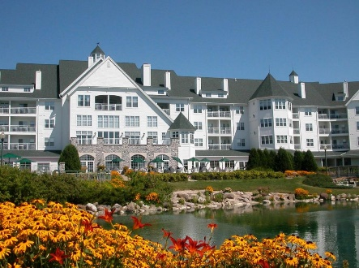
The cut-off date to book a room is Friday, September 9, 2022
*Rates are not guaranteed for reservations past the above cut-off date or in the event of a sellout prior to the cut-off date.

To Book Your Reservation Today
Call 1-800-876-3399
Ask for: Wisconsin Correctional Association

PLEASE NOTE
- All reservations must be guaranteed and accompanied by a first night room deposit.
- Cancellation of room reservations: Deposits (taken either in cash or by credit card) are refunded or credited, minus a $50 processing fee, only if notice is received 7 days prior to arrival date and cancellation number is obtained by guest. Guests are responsible for paying for one night’s room and tax if the reservation is cancelled with less than 7 days notice.
- Check in is at 4:00 pm - Check out at 11:00am
- Credit Card Verification & Photo ID required at check-in
- A credit card is required to guarantee your reservation
- Guest room rates are subject to applicable state & local taxes
- Any coupons, discounts, special rates, packages, or any other individual offers will not apply

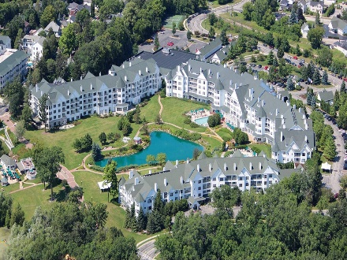

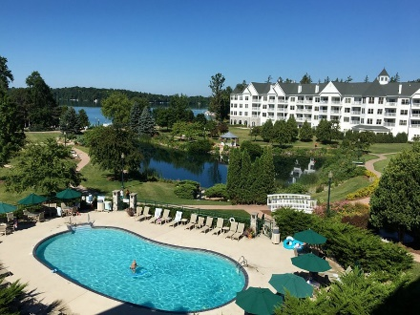

SHIPMENT INFORMATION
All shipments must be received by the Osthoff Resort no more 2 days prior to the conference. Boxes must be labeled as follows:

Contact Name: Ashley Melanson
Group Name: Wisconsin Correctional Association
Conference Service Manager: Jason Schnicke
Arrival & Departure Date: __________________________
c/o The Osthoff Resort
101 Osthoff Avenue
Elkhart Lake, WI 53020
Box __ of __

Full Conference Schedule for Exhibitors & Sponsors
Sunday, October 2nd
3:00pm – 4:30pm Booth Set up
6:00pm – 7:00pm Exclusive Dinner with WCA Board of Directors and Conference Committee
Private Room
7:00pm – 9:00pm President’s Welcome Reception with WCA Board of Directors, Committee, Exhibitors and Attendees
Conference Registration
9:00pm – 9:30pm Booth Set up

Monday, October 3rd
6:00am – 7:00am Booth Set up
7:00am Conference Registration
Lobby
7:30am – 8:00am Breakfast with the Exhibitors

8:00am – 8:30am Opening Ceremony
LaBelle Ballroom
8:30am – 9:30am Keynote Speaker
LaBelle Ballroom
9:30am – 10:00am Break with the Exhibitors
Sandstone Ballroom
10:00am – 11:30am Breakout Session # 1
See breakout descriptions for locations
11:30am – 12:00pm Time with the Exhibitors

12:00pm – 1:30pm Awards Luncheon
LaBelle Ballroom
1:30pm – 3:00pm Breakout Session # 2
See breakout descriptions for locations
3:00pm – 3:30pm Break & Networking with Exhibitors

3:30pm – 5:00pm Breakout Session #3
See breakout descriptions for locations
5:00pm – 5:30pm Stamp Card Raffle Drawing
LaBelle Ballroom
5:30pm – 6:00pm Booth Breakdown
6:30pm – 7:30pm Social Networking Hour
LaBelle Ballroom
7:30pm – 11:00pm Entertainment with appetizers
LaBelle Ballroom

Tuesday, October 4th
7:00am - 7:45am Networking Buffet Breakfast
LaBelle Ballroom
8:00am – 12:45pm Keynote speakers & breakout sessions
LaBelle Ballroom & see breakout descriptions for locations
12:45pm – 2:00pm Scholarship Luncheon, Raffle Drawing and Swearing-In of New Board Members
LaBelle Ballroom

